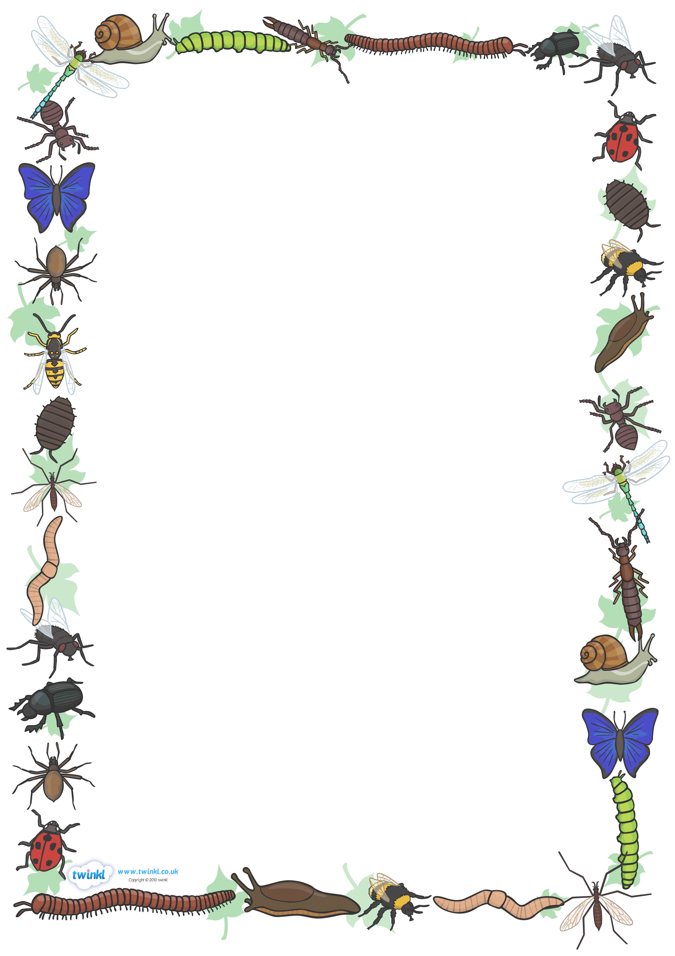
Reception Homework
“Why do ladybirds have spots?”
Let’s learn about bugs! Next term Reception will be learning all about insects and minibeasts. They will be learning about the life cycles of different creatures and how they change from birth to adults. We might even have a few insects in the classroom to help them!
At Longwood we offer homework in a variety of ways. Your child may choose from the following projects or make-up their own and can complete as many as they wish:
- Go on a bug hunt in your garden or in a local park. What did you find? Take photos or record the results.
- Make an insect hotel for your favourite insect. What do they need? How should you look after them?
- Read lots of books about minibeasts, you could go to the library! Choose a few of your favourite facts to write down and send in.
- Paint or draw some ladybirds, can you add the spots on their backs on find out how many there are altogether?
- Write a list of all the different insects that you can think of.
It doesn’t matter if it’s not perfect – encourage them to have a go by themselves at first ☺

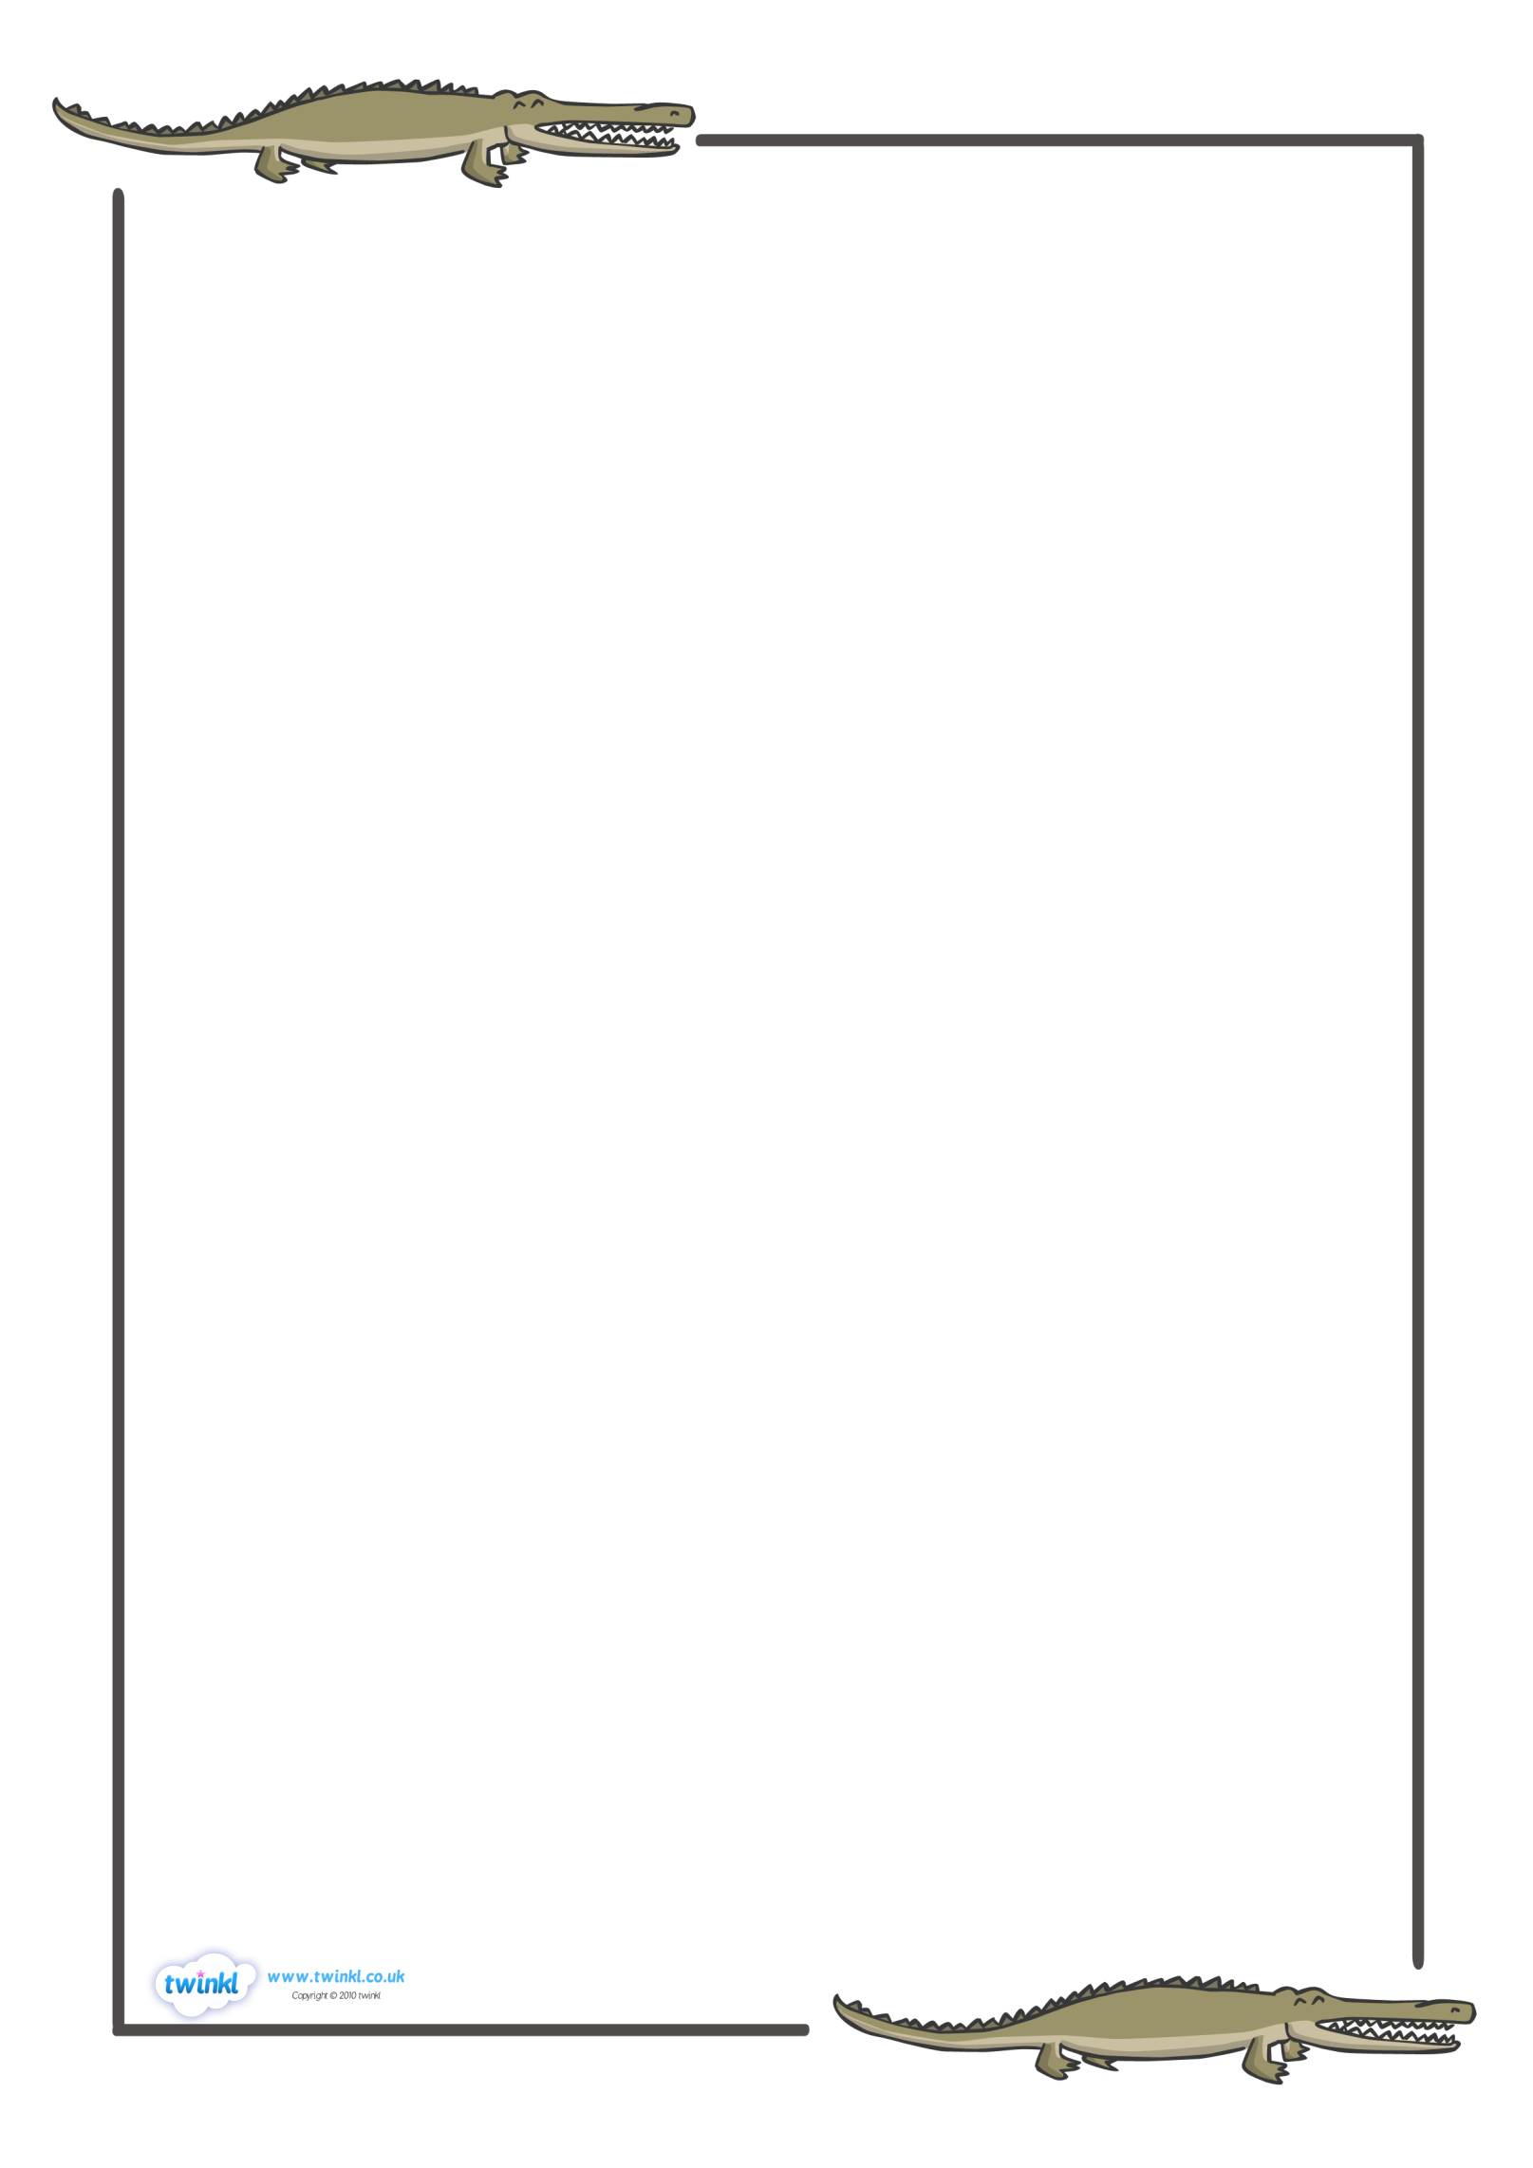
TEXT HERE
Parents – how to help your child:
- Ensure that your child brings their library book to school every Monday and their home readers/tricky word tubs on a Friday (if they have one).
- Practice adding to 20 using objects/bar modelling and doubling, e.g. 8+8.
- Encourage your child to read their tricky words and books as often as possible.
- Point out numbers in the environment and ask them one more.
- Encourage them to be writing proper sentences about anything that they like using their phonic fingers.
- Happy homeworking! We look forward to seeing it all soon!
Thank you, Miss Ranch & Miss Whyley☺

