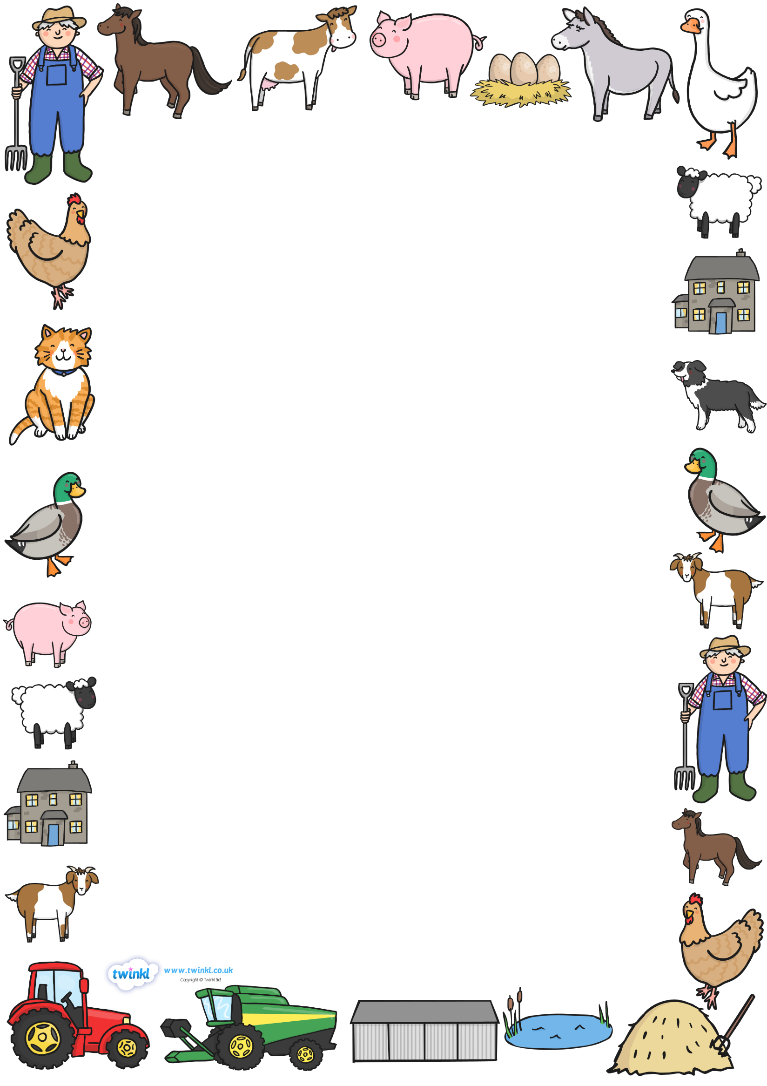
Reception Homework
“Do cows drink milk?”
Let’s find out about farms! Next term Reception will be learning all about farms, the animals that live there and the food that farms produce. They will be learning the life cycles of different animals and how they change from birth to adults. They will be using their memories, photographs and videos from our trip to Ash End Farm to help them.
At Longwood we offer homework in a variety of ways. Your child may choose from the following projects or make-up their own and can complete as many as they wish:
- Make a farm animal model. Can you find out information about your model animal such as what they eat?
- Make a home for your favourite animal. What do they need? How should you look after them?
- Read lots of books about animals. Choose a few of your favourite facts to write down and send in.
- Paint a farm scene and label the animals.
- Write about your trip to the farm.
- Write a shopping list for food that comes from farms or take a picture of you trying some!

TEXT HERE
Parents – how to help your child:
- Read stories to your child as often as possible and if they are ready to, get them to read to you.
- Point out numbers in the environment and practice writing them.
- Encourage your child to notice shapes in the environment, e.g. sphere for footballs, cylinders for water bottles.
- Ask your child to help you write a shopping list and get them to sound it out, e.g. h-a-m, p-a-s-t-a
- Happy homeworking! We look forward to seeing it all soon!
Thank you, Miss Ranch & Miss Whyley ☺

DUE FRIDAY 28TH FEB

