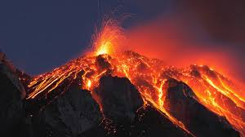

Year 3
Homework Guide
Summer 2
Our family fun homework project this term is based around our theme: Tremors
Please pick any of the following suggestions or you may wish to pick your own project based on our theme.

Project suggestions
- With a parent or carer, create your own mini erupting volcano using baking soda and vinegar. Wow! Take photographs to show how you made it.
- Design a poster to show a volcano’s main features. Make sure you label its important parts!
- Research a volcanic eruption of your choice (not one you’ve studied in class). Produce a fact file about the eruption including a sketch map to show its
- Find out why people still live close to volcanoes despite the risks. Think about soil, new land, building materials, mineral deposits, hot springs and spas, electricity and tourism. Be ready to share your ideas in class.
- Imagine you have just survived an earthquake. Write a short story about what happened. Make sure you include factual information such as the earthquake’s strength. Use geographical words in your account such as tremor, seismic isolator, aftershock, epicentre.
- Design an earthquake-proof house. How could you prevent the building from collapsing during an earthquake?

Your project needs to be brought into school by the end of the second week to share with the class.
If you have any questions please do not hesitate to ask.

