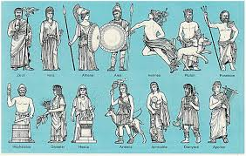

Year 3
Homework Guide
Spring 1
Our family fun homework project this term is based around our theme: Gods & Mortals
Please pick any of the following suggestions or you may wish to pick your own project based on our theme.
Project suggestions
- Read and re-tell the story of Medusa, the Gorgon, who could turn people to stone if they looked at her. Illustrate your story with a detailed drawing of Medusa’s face showing her hair of venomous snakes.
- Design your own mythical creature. Which animals’ body parts could you include in your design? What personality will your creature have? Make your creature using junk materials and give it a fabulous name!
- Look carefully at the shapes of the letters of the Greek alphabet. Practise forming them and pronouncing them. Can you teach the alphabet to your family?
- Be inspired by Greek art! Look at online examples of pottery and create your own design for an ancient Greek jug or bowl. You could choose a scene from Greek mythology to represent in your artwork or maybe another familiar story. Remember to use colours typical of Greek art such as black, white, red and yellow.
- Spot buildings influenced by Greek architecture around your nearest town or city and take photographs to show in school. Hunt for columns, statues or pillars. Find out about different types of column (Doric, Ionic, Corinthian) and see if you can identify any of these on your hunt.
- Find out about famous Greek philosophers such as Plato, Aristotle, Archimedes and Pythagoras. How did their work influence life today? Make a scrapbook using downloaded images and drawings and write informative sentences and captions.

Your project needs to be brought into school by the end of the second week to share with the class.
If you have any questions please do not hesitate to ask.

