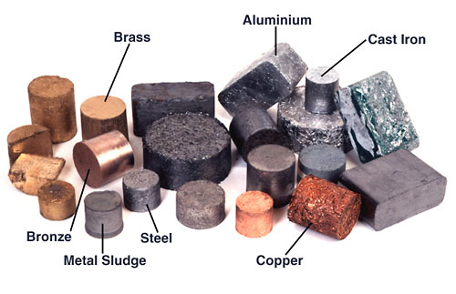
Year 3
Homework Guide
Autumn 2
Our family fun homework project this term is based around our theme: Mighty Metals.
Please pick any of the following suggestions or you may wish to pick your own project based on our theme.
Project suggestions
Your project needs to be brought into school by the end of the second week to share with the class.
If you have any questions please do not hesitate to ask.
- Go on a magnetic treasure hunt in your house. How many magnetic objects can you find? What materials are they made from?
- Research some of the tasks carried out by robots. What tasks do you think robots could do in the future? What jobs would you like a robot to do in your house? Ask your parents – they’re sure to have some ideas!
- Investigate the best surfaces at home for toy cars to travel on; carpet or tiled floor?
- Use non-fiction books and the web to find out and write facts about a metal of your choice.
- Read stories and poems about robots. Choose your favourite, then write or film a review for classmates.
- Design your perfect playground. What (real or imaginary) equipment would you include?
- Search the web for to find artwork made using metal and make a collage or scrapbook of downloaded images.

