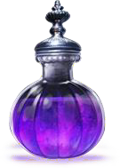

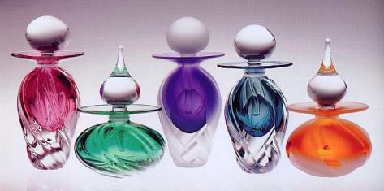
- Make a list of all the solids, liquids and gases you can find at home. Are they kept safely?
- Make a sketch of any interesting bottles you have at home. Remember to add patterns, textures, shading and finer details!
- Make home-made perfume or potions using things you find in the garden or bathroom. (Check with an adult before you
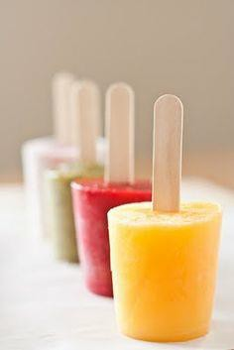
start about which substances are safe to use.) Use a pestle and mortar to grind up the things you find. Add liquid and strain to get rid of the lumpy bits! What have you
made?
- Calculate how many litres of water it takes to fill your bath. Which uses less water, the shower or the bath? How can you find out?
- Make ice lollies at home. Can you add a surprise ingredient that reveals itself as the ice melts?
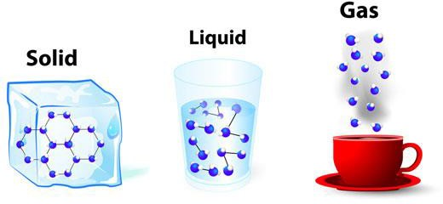
- Visit your local library or book shop to search for other plays and stories on the theme of potions. Write a book review and share it with others in your class.

