- Write some number calculations using Roman numerals for your friends to solve.
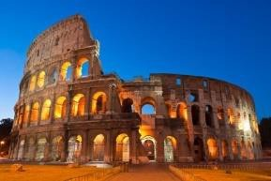
- Watch the closing credits of your favourite British TV programme. Can you find the Roman numerals at the end? What year was your programme made?
- Find out the dates of birth of your family and friends and record them in Roman numerals.
- Research Roman life using books from your local library. Which were most useful? Recommend the best one to your classmates.
- Find out if there are any Roman forts or settlements near where you live. Try to visit one with your family. Take lots of photographs of what you see.
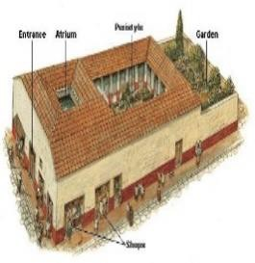
- Look at Roman artefacts in detail at a local museum or on the British Museum website. Create a PowerPoint presentation showing the artefacts that most interest you and provide information about what they were used for.
- Look at holiday brochures and online information to find out about modern day Rome as a tourist destination. Which tourist attractions would you visit? What is the weather like? Where else would you like to go in Italy?
- Try to find a map of Roman Britain. Find out about some of the names of towns and cities. What are their modern names?
- Read a book or watch a film on a Roman theme. Write a review to let your classmates know what you thought about it.
- Write a diary entry as if you are a Roman soldier, a slave in a Roman villa or a Celtic child. What is your typical day like?
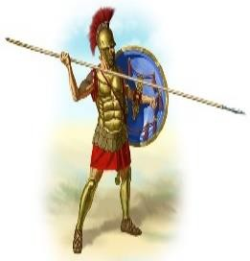
- Use an online translation tool to write well-known phrases in Latin, the language of the Romans. Perhaps you could write a birthday (or seasonal) greeting?
- Find some proverbs with Roman origins. Choose one and write it in your best handwriting with a suitable illustration. Can you explain to your family what it means or what advice it gives?
- Create a wordsearch or crossword puzzle containing some of the key Roman vocabulary you have learnt. Bring your puzzle to school for your friends to solve.
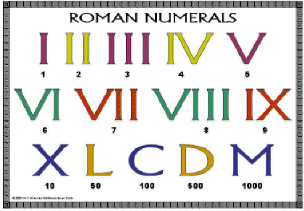
- Make a model of a Roman villa using junk materials such as cereal boxes, coloured paper, tin foil and cardboard tubes. Use online images and pictures in non-fiction books to inspire the layout of your villa.
- Create a multiple choice quiz on the theme of Roman life. Try it out on your family, then bring it to school and test your friends. Make sure you research and check the answers carefully!
- Make a drawing of a Roman god or goddess. Write a fact file of information about them.
- Create your own Celtic costume. Tartan pyjama bottoms and blankets may come in handy! You could borrow a brooch to secure your cloak or some Celt-inspired jewellery. Hair gel and blue face paint are essential if you are going into battle!

