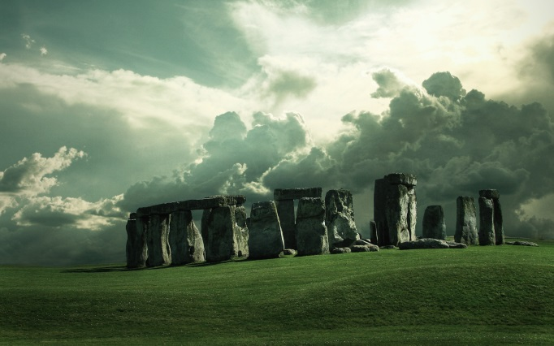
Year 3
Homework Guide
Spring 2
Our family fun homework project this term is based around our theme: Tribal Tales
Please pick any of the following suggestions or you may wish to pick your own project based on our theme.

Project suggestions
- Write your own prehistoric adventure story. Will you set it in the Stone Age, Bronze Age or Iron Age? Make sure your story reflects the time it is set.
- Find out more about rock art – human-made markings placed on natural stone.
- Draw your own pet or local animal (cat, dog, hamster, rat!) in the style of a prehistoric cave painting.
- We know about prehistoric life from artefacts that have been found, such as food, coins, tools and jewellery. What might historians of the future find out about you from your everyday belongings?
- Write a newspaper report about a find 1000 years in the future.
- Use your local library to research the Stone Age, Bronze Age and Iron Age history of your local area.
- Are there any sites to visit or can you find any relevant online images or news stories?
- Iron Age people started growing crops such as spelt wheat, barley, rye and oats. Can you find these foods in your local shops? Can you find out where these crops are grown now? List your findings in a table.
- Make a photo montage of prehistoric monuments.

Your project needs to be brought into school by the end of the second week to share with the class.
If you have any questions please do not hesitate to ask.

