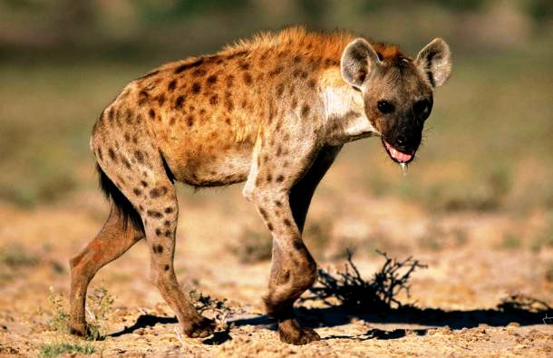
Year 3
Homework Guide
Spring 2
Our family fun homework project this term is based around our theme: Predator
Please pick any of the following suggestions or you may wish to pick your own project based on our theme.

Project suggestions
- Visit the local library to find non-fiction books about predators. Look for information using contents, glossary and index pages.
- Write down any new facts you have learnt and bring them in to share with the class.
- List five or more predators into the sub-groups: Mammals; Birds; Crustaceans; Insects; Arachnids; Reptiles; Fish; and Plants.
- Make a mini fact file or short digital presentation about your favourite predators and bring it into school to share with the class.
- Make your own non-fiction book about a predatory animal – maybe your pet cat?
- If you could be a predator for the day, what kind of predator would you be, and why? Where would you live? What features would help you hunt, catch and kill your prey? Record your ideas on paper and bring them in to share with the class.
- Use the web to research what different predators eat. Create food chains for a variety of different predators using materials and tools of your choice.

Your project needs to be brought into school by the end of the second week to share with the class.
If you have any questions please do not hesitate to ask.

